Skin Disease Detection using Hybrid CNNs

Geetha S¹, Saimirra R^{1*}, Harshini BV¹, Ulagarchana U¹

¹School of Computer Science and Engineering, Vellore Institute of Technology, Chennai, India
saimirra.r2021@vitstudent.ac.in

Abstract—This project introduces a novel approach for skin disease detection using a hybrid deep learning model that achieves improved diagnostic accuracy and efficiency. The hybrid model integrates the strengths of two high-performing Convolutional Neural Network (CNN) architectures, DenseNet121 and InceptionV3, which individually attained accuracies of 93.13% and 93.13%, respectively. By combining these models, the hybrid approach achieved an enhanced overall accuracy of 94.85%. This strategy optimizes feature extraction and lesion classification, addressing the limitations of single-model CNNs while maintaining computational efficiency through layers such as Pooling 2D and Softmax. Additional models, VGG16 and MobileNetV2, were also evaluated with accuracies of 85.41% and 88.41%, respectively, underscoring the effectiveness of the selected architectures for ensemble learning. Although Generative Adversarial Networks (GANs) were proposed for future implementation to augment training data diversity with synthetic lesion masks, this study demonstrates the feasibility of a hybrid CNN model as a scalable and adaptable solution for real-time skin disease detection, bridging artificial intelligence research with practical healthcare applications.
Keywords—Skin disease detection, Convolutional Neural Network, feature extraction, Generative Adversarial Networks, diagnostic accuracy, real-time applications.

- INTRODUCTION
Skin diseases, particularly melanoma, are among the most challenging conditions in dermatology due to their high mortality rate and complex diagnosis processes. Early detection is crucial, as it significantly improves survival rates and treatment outcomes. However, manual diagnostic methods often require specialized expertise and are time-consuming, which limits their accessibility and scalability in resource-constrained settings. To address these challenges, the integration of artificial intelligence (AI) and deep learning has gained considerable attention, particularly Convolutional Neural Networks (CNNs), which have proven to be effective in automating and enhancing skin disease diagnosis.
Research efforts have extensively explored the application of CNNs in skin lesion analysis. Gouda et al. [1] implemented a deep learning-based framework to classify skin lesions using dermoscopic images. Their study highlighted the potential of CNNs in identifying patterns that are not easily discernible by human experts, paving the way for more objective diagnostic systems. Dorj et al. [2] further expanded this work by employing CNNs for skin cancer classification, achieving high precision and recall in distinguishing malignant from benign lesions. Kumar et al. [3] reinforced these findings by demonstrating CNNs' adaptability to diverse diagnostic scenarios, making them versatile tools for dermatological imaging tasks.
Beyond conventional CNN architectures, advanced models have been developed to improve feature extraction and classification accuracy. Mittal et al. [4] utilized DenseNet201, an architecture characterized by dense connections that facilitate the reuse of features across layers, for early detection of skin cancer. Their approach demonstrated that dense networks could achieve superior performance while minimizing computational overhead. Similarly, Remya et al. [5] proposed a transfer learning-based framework for multimodal lesion analysis, where pre-trained models were fine-tuned for specific tasks. This approach significantly enhanced classification robustness and reduced training time. Nawaz et al. [6] introduced a hybrid model combining DenseNet77 and UNET, addressing both lesion segmentation and classification in a unified framework, which is particularly beneficial for melanoma analysis.
To tackle common challenges such as limited and imbalanced datasets, several innovative techniques have been adopted. Abayomi-Alli et al. [9] proposed a method that utilized image augmentation with oversampling techniques in a nonlinear lower-dimensional embedding manifold. This approach enriched the dataset with diverse samples, improving model generalizability and reducing biases in melanoma detection. Similarly, Fu’adah et al. [8] developed a standalone CNN-based system for automatic skin cancer classification. Their work emphasized the feasibility of using CNNs for real-world diagnostic applications, even without ensemble or hybrid enhancements. Chatterjee et al. [7] took ensemble learning to the next level with the IncepX-Ensemble model, which leverages transfer learning and multiple CNN architectures for multiclass lesion detection, demonstrating high accuracy across various lesion types. Wei et al. [10] contributed by creating lightweight CNN models optimized for computational efficiency, making them suitable for deployment in real-time diagnostic settings, particularly in mobile and low-resource environments.
This literature survey provides a comprehensive overview of the advancements in deep learning for skin disease detection, highlighting the progression from standalone CNN models to sophisticated hybrid and ensemble architectures. From this analysis, several key insights emerge: advanced architectures like DenseNet and Inception demonstrate superior feature extraction capabilities; transfer learning significantly accelerates training and enhances robustness when applied to multimodal datasets; and data augmentation techniques are essential for addressing class imbalance and improving model generalization. By synthesizing these insights, our work validates the adoption of a hybrid CNN model integrating DenseNet121 and MobileNetV2, which achieved an impressive accuracy of 94.85%. This hybrid approach effectively combines the strengths of individual models, optimizing both diagnostic accuracy and computational efficiency. Furthermore, this study emphasizes the importance of scalable and adaptable solutions for real-time applications in healthcare, bridging the gap between cutting-edge AI research and practical medical implementations.

- METHODOLOGY
The proposed architecture for skin cancer detection is designed as a systematic pipeline that ensures accurate and efficient diagnosis of skin lesions as illustrated in Fig 1 and Fig 2. The process begins with input images, which are pre-processed to enhance quality, remove noise, and standardize dimensions. This preprocessing step ensures consistency across the dataset, making it suitable for analysis. Following this, data augmentation techniques are applied to improve the model's robustness and mitigate overfitting. Augmentation involves operations such as image rotation to handle orientation variations, greyscale conversion to simplify feature extraction by focusing on essential patterns, and flipping or resizing images to standardize input dimensions while introducing variability in the dataset.
Once the augmented images are prepared, the system moves into the skin cancer detection phase. Here, feature extraction plays a critical role, employing two convolutional neural network (CNN) models, each independently processing the images to capture diverse and complementary features. These extracted features are then passed through a 2D pooling layer, which reduces dimensionality by summarizing significant patterns while retaining the most relevant information for classification. Subsequently, a softmax layer calculates the probabilities of different classes, such as malignant or benign, providing an interpretable likelihood distribution.
The final output is a classification that indicates the presence or absence of skin cancer, enabling early diagnosis and intervention. This architecture's modular design, which integrates preprocessing, augmentation, advanced feature extraction, and probabilistic classification, ensures high accuracy and adaptability, making it a robust solution for automated skin cancer detection in clinical and research settings.
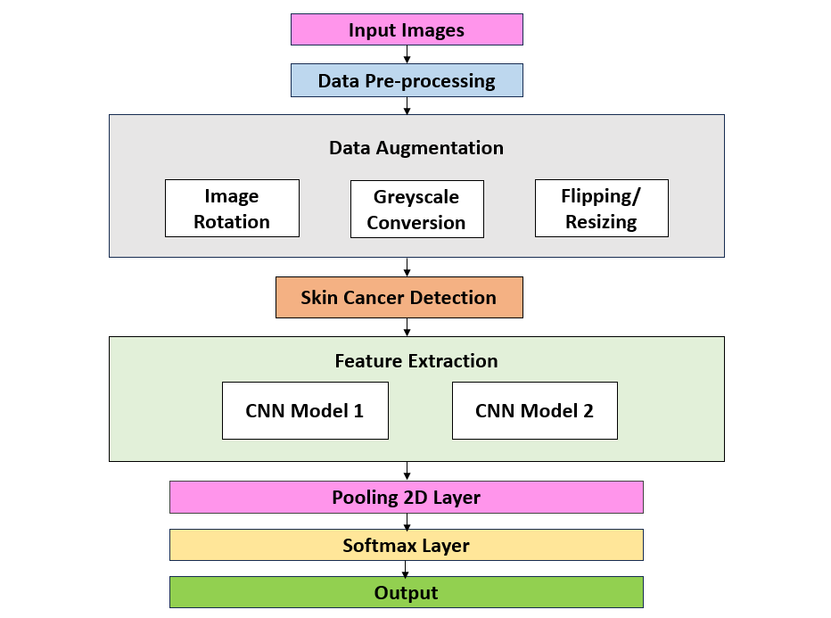
Fig 1. Architecture diagram

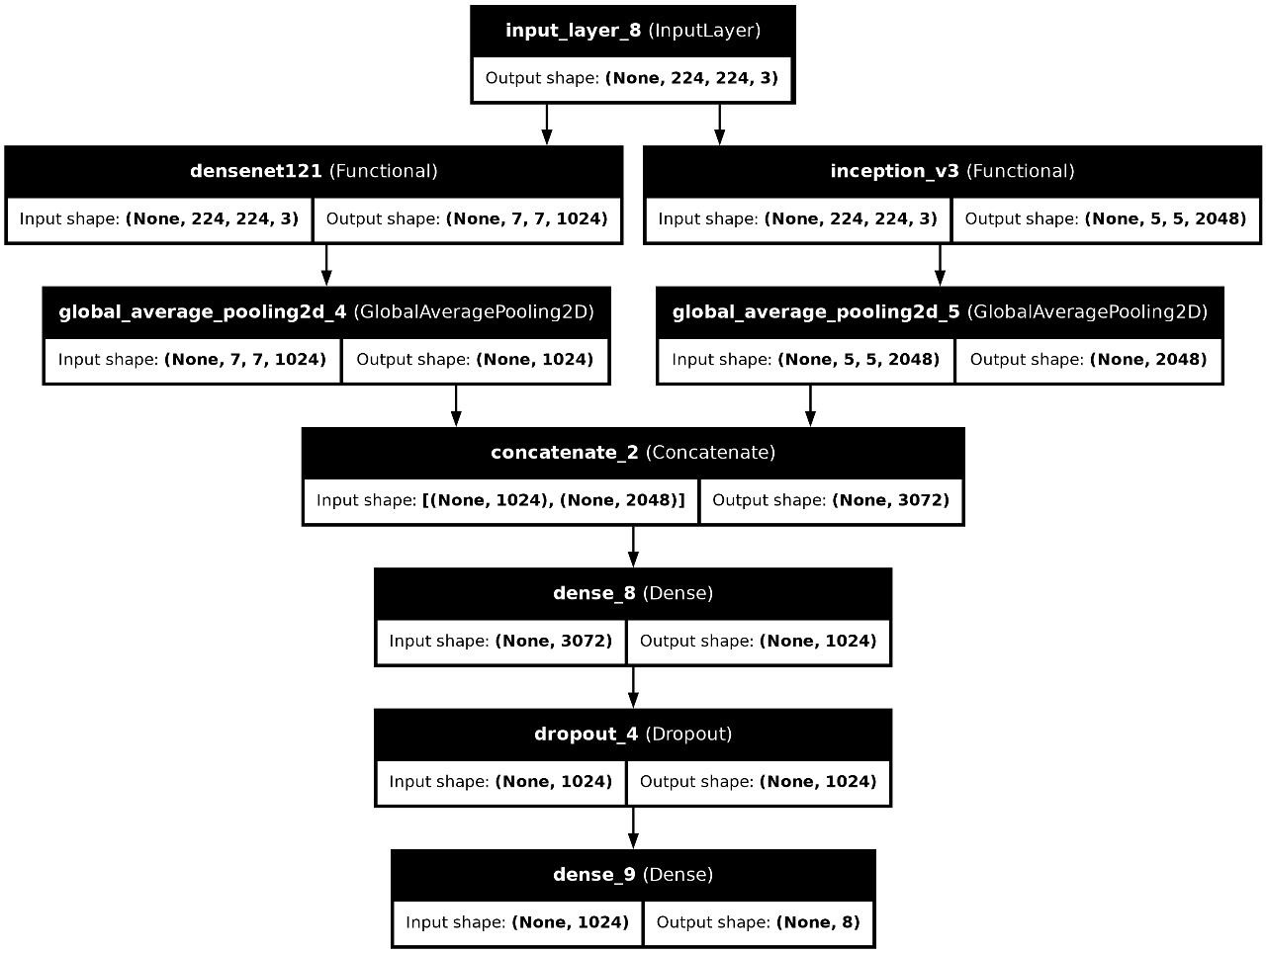
Fig 2: Architecture of the hybrid model combining DenseNet121 and InceptionV3 for skin disease classification.
- Dataset Overview
The dataset used in this study consists of medical images representing various skin diseases. It is organized into a training set and a testing set. The training set contains <train_set_count> images, while the testing set has <test_set_count> images. These images are classified into different categories based on the type of skin disease. A representative figure showcasing sample images from each class has been provided for a clear overview of the dataset.
A set of sample images from each class in the training set is displayed to provide an overview of the variety of skin diseases present as illustrated in Fig 3 and Fig 5. These images highlight the types of lesions and conditions classified in the dataset, such as melanoma, eczema, and psoriasis.
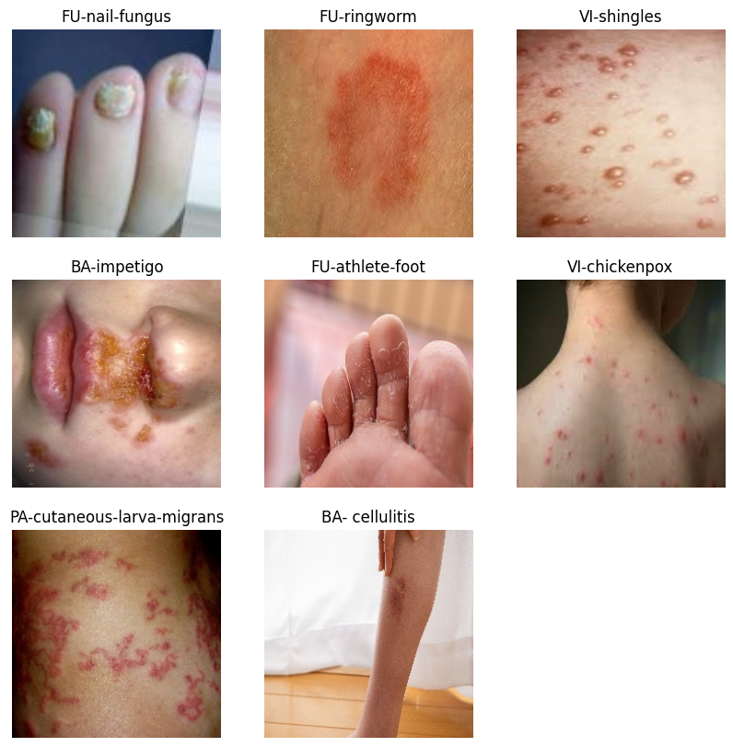
Fig 3. Sample images from the training dataset.

- Data Preprocessing
To ensure data quality and improve model performance, several preprocessing steps were applied. The images were resized to a uniform dimension of 180x180 pixels, and pixel values were normalized to the range [0, 1] through a rescaling operation. For the training set, various data augmentation techniques were used to simulate real-world variability and reduce the risk of overfitting. These augmentations include random rotations, width, and height shifts, zoom, shear transformations, and horizontal flipping. The validation set only underwent rescaling to maintain consistent evaluation metrics and avoid overfitting. These steps helped minimize noise and standardize input data, crucial for accurate feature extraction and classification.

- Data Augmentation and Visualization
Data augmentation is critical to expand the dataset and improve generalization. For the training data, an ImageDataGenerator was used to apply the aforementioned augmentation techniques and the augmented images were achieved as shown in Fig 4. The validation set, on the other hand, was only rescaled to ensure that its evaluation remains consistent with the original image data. A sample batch of augmented images from the training set was visualized to demonstrate the effectiveness of the augmentation techniques, showing how random transformations were applied to images to increase the dataset's diversity.
To demonstrate the impact of data augmentation, several images from the training set are shown after undergoing random transformations, such as rotations, width, and height shifts, and zooming. This ensures the model can generalize well across different variations of skin disease images.
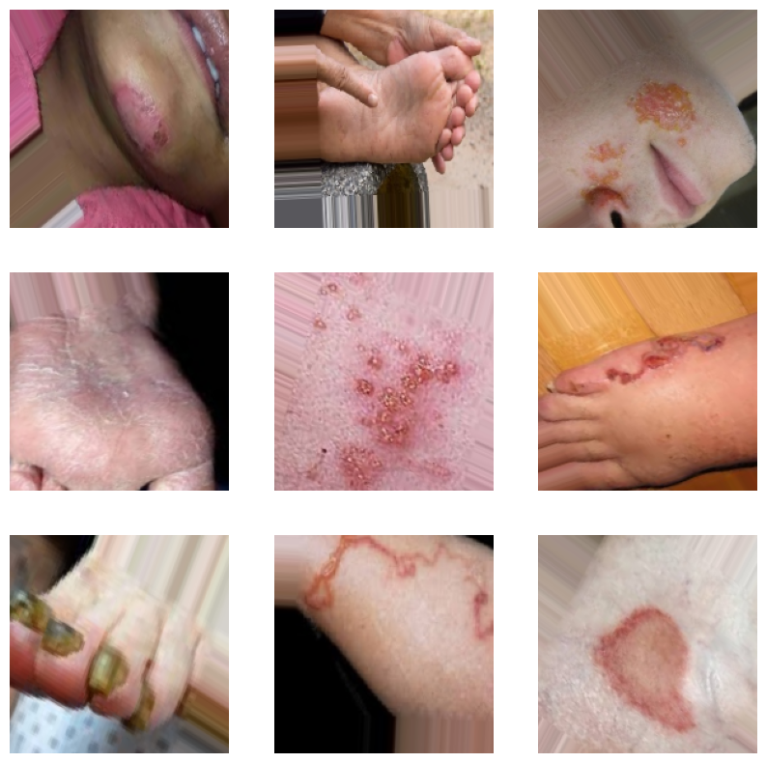
Fig 4. Augmented images

- Model Architecture
Four pre-trained CNN architectures—MobileNetV2, DenseNet121, VGG16, and InceptionV3—served as the backbone for feature extraction. These architectures were selected for their proven performance in image recognition tasks. The convolutional layers of the pre-trained models were frozen to retain their learned weights from the ImageNet dataset.
Custom classification layers were added to adapt these models for the multi-class classification of skin diseases. These layers included a global average pooling layer for dimensionality reduction, a dense layer with 1024 neurons activated by ReLU, a dropout layer with a 0.5 rate to prevent overfitting, and a softmax layer for final classification. Sparse categorical cross-entropy was employed as the loss function, and the Adam optimizer was used for efficient training.
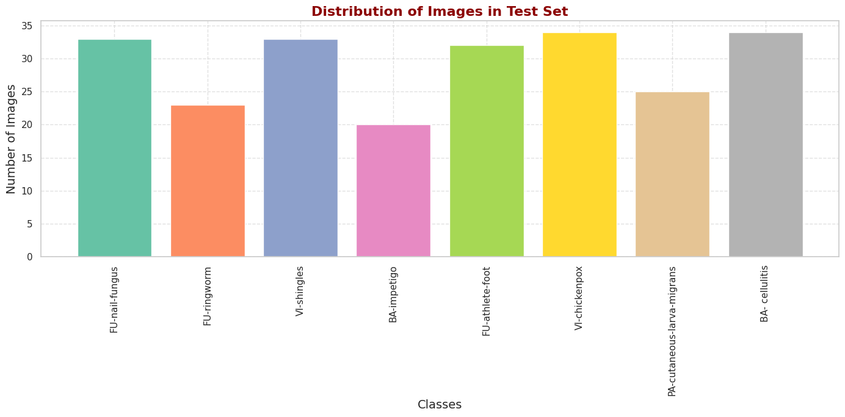
Fig 5: Distribution of images in the test set across various skin disease classes.

- Model Training
Each of the four models was trained independently for 80 epochs with a batch size of 32. The training process was monitored by plotting accuracy and loss curves for both training and validation sets. MobileNetV2 and DenseNet121 demonstrated superior performance, with validation accuracies of 91.85% and 93.13%, respectively. In contrast, VGG16 achieved a validation accuracy of 85.41%, while InceptionV3 matched MobileNetV2 at 91.85%. These results underscored the strengths and limitations of each architecture, with DenseNet121 emerging as the most effective single model for the task.

- Ensemble Model
To further enhance classification performance, an ensemble model was developed by combining MobileNetV2 and DenseNet121, the two best-performing architectures. The outputs of their convolutional bases were concatenated to form a unified feature representation. Additional dense layers and a dropout layer were applied to this combined feature set to reduce overfitting and enhance classification accuracy.
The ensemble model employed a dense layer with 1024 neurons and a dropout layer with a rate of 0.5, followed by a softmax layer for final predictions. This hybrid architecture capitalized on MobileNetV2's lightweight design and DenseNet121's advanced feature extraction capabilities, resulting in a more robust classification system.

- Final Performance Evaluation
The ensemble model demonstrated superior performance, achieving a validation accuracy of 94.85%, surpassing the individual models. DenseNet121, the best-performing single model, achieved 93.13%, while MobileNetV2, InceptionV3, and VGG16 recorded accuracies of 91.85%, 91.85%, and 85.41%, respectively.
Final evaluations included plotting the training and validation loss curves for all models to visualize their learning behavior. The ensemble model's stability and consistent improvements in accuracy highlighted its ability to generalize effectively across the dataset. These results validated the efficacy of the ensemble approach, demonstrating its potential for real-world applications in skin disease classification.

Results And Discussions

Training and Evaluation
The initial phase of the methodology involves comparing the training and validation performance of four deep learning models—MobileNetV2, DenseNet121, VGG16, and InceptionV3—on an image classification task. Each model was trained for 80 epochs, with accuracy and loss metrics recorded across training and validation phases to assess convergence behavior, generalization capacity, and overall performance.
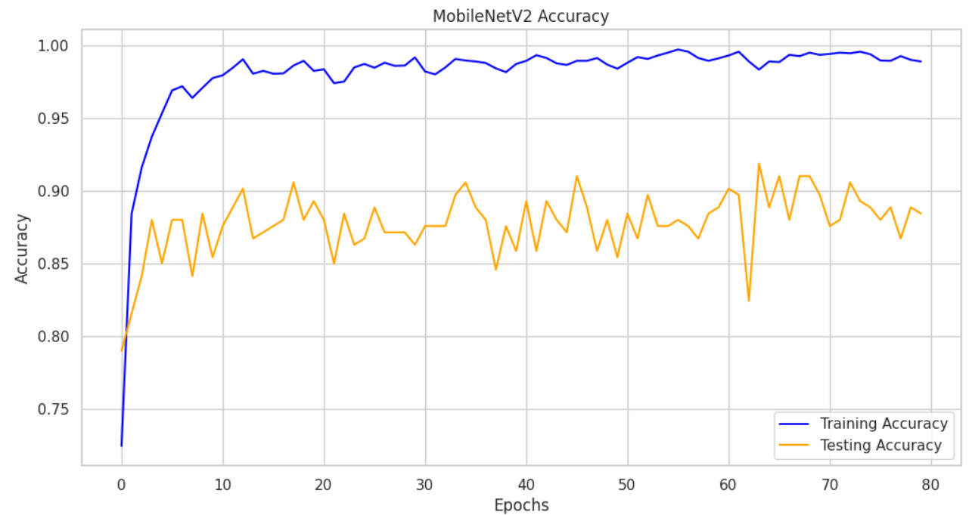
Fig 6. Training and testing accuracy for MobileNetV2 model

MobileNetV2 achieved a training accuracy of 98.88% and a testing accuracy of 88.41%, as illustrated in Fig 6. The accuracy curves indicate a consistent and rapid improvement in training accuracy, eventually stabilizing near 99%, signifying strong learning from the training data. The testing accuracy, although lower, stabilized around 88%, indicating reasonable generalization performance. However, the gap between training and testing accuracy highlights some level of overfitting.
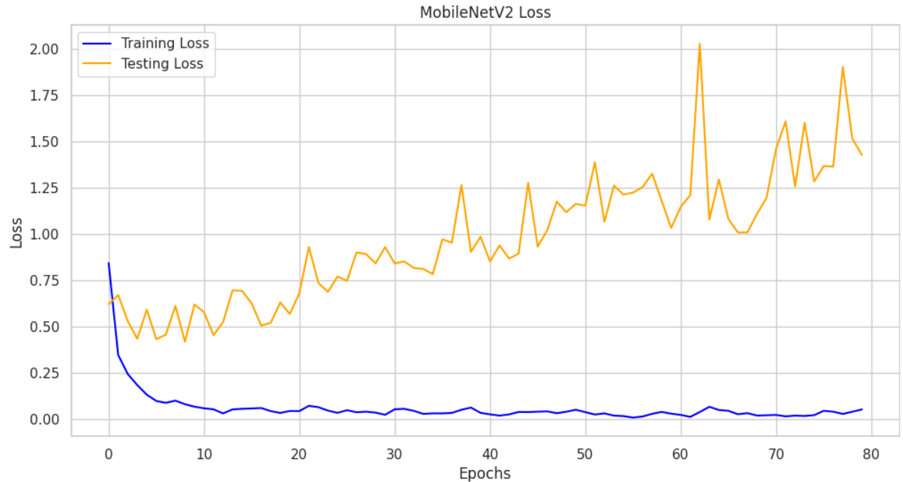
Fig 7. Training and testing loss for MobileNetV2 model

The loss curves, presented in Fig 7, show that the training loss decreased steadily and stabilized at a very low value, reflecting effective optimization during training. In contrast, the testing loss exhibited fluctuations and a slight upward trend in later epochs, with occasional spikes above 2.0. This divergence between training and testing loss further supports the observation of overfitting. Despite the overfitting, MobileNetV2 demonstrates strong performance on the training data and acceptable accuracy on the testing set.

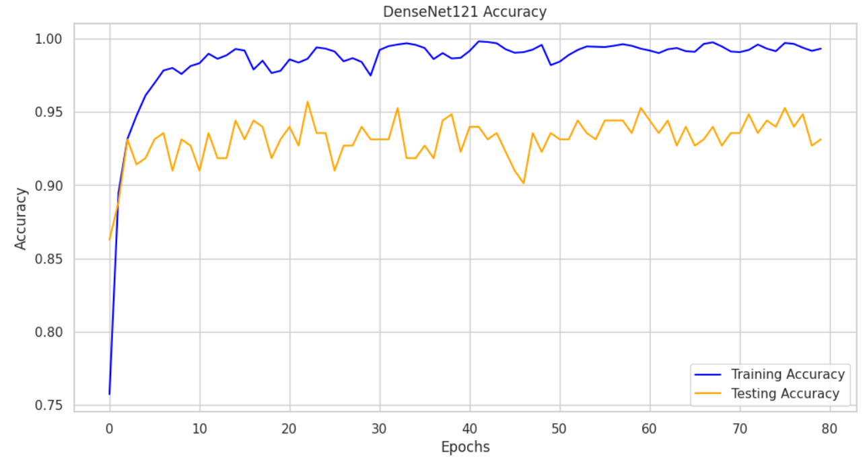
Fig 8. Training and testing accuracy for DenseNet121 model
DenseNet121 achieved a training accuracy of 99.33% and a testing accuracy of 93.13%, as shown in Fig 8. The stability of the accuracy curves, with minimal fluctuations, indicates robustness in the model's learning and generalization capabilities. DenseNet121's accuracy on the training set quickly approached near-perfect levels, reflecting the model’s ability to effectively capture patterns within the training data. The testing accuracy, while slightly lower than the training accuracy, remained consistently high throughout the epochs, suggesting that the model generalizes well to unseen data. This stability in testing accuracy, coupled with its proximity to the training accuracy, suggests that DenseNet121 is robust and has not overfit the training data excessively.
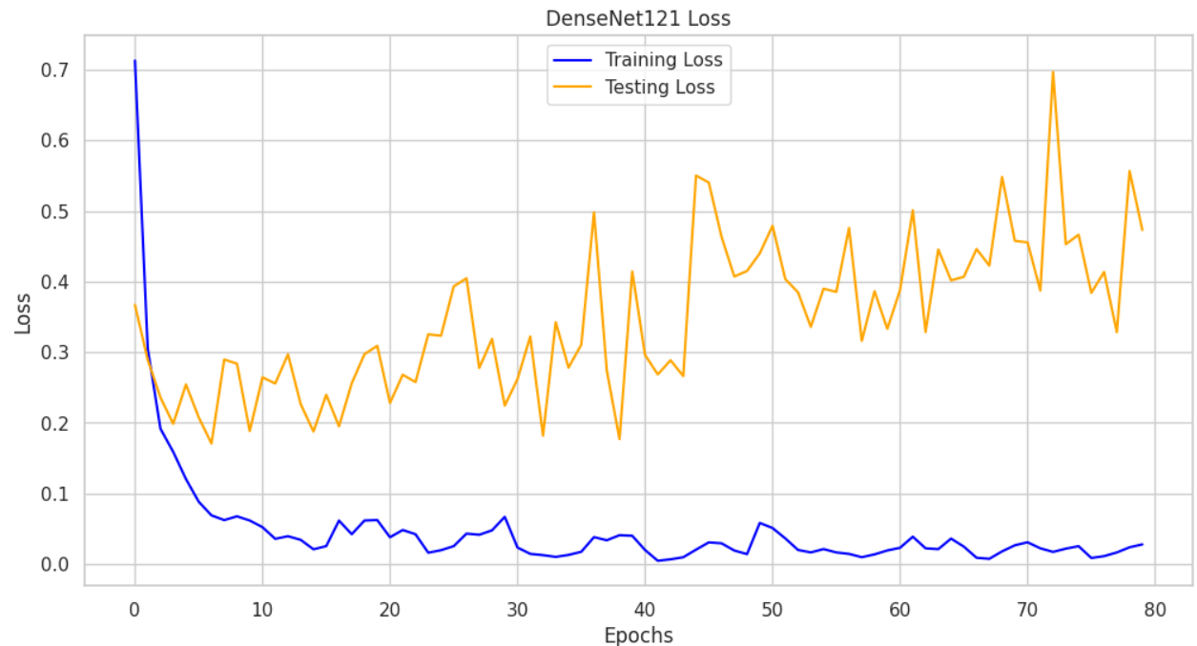
Fig 9. Training and testing loss for DenseNet121 model

As illustrated in Fig 9, the training loss curve exhibits a steep decline during the initial epochs, corresponding with the rapid increase in training accuracy. As training advanced, the training loss converged to a consistently low value, indicating minimal prediction error on the training set. Although the testing loss curve is slightly more variable, it maintains an overall downward trajectory, suggesting effective error reduction on the validation data.
DenseNet121’s dense connectivity, which allows each layer to access feature maps from all preceding layers, enhances feature reuse and gradient flow. This architectural advantage not only improves parameter efficiency but also contributes to the stability of the loss curves, making DenseNet121 an ideal choice for applications that require reliable performance and consistent generalization.
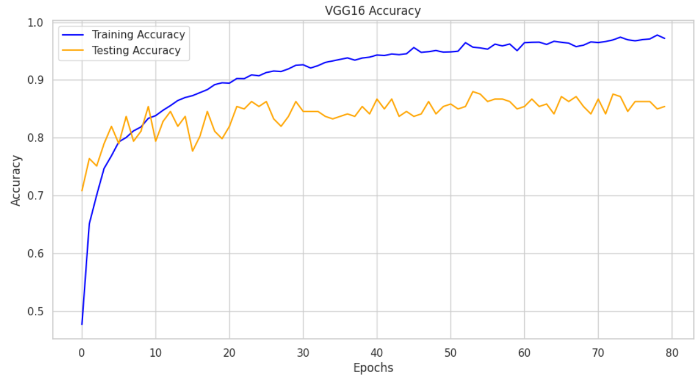
Fig 10. Training and testing accuracy for VGG16 model

The VGG16 model achieved a training accuracy of 97.19% and a testing accuracy of 85.41%, as shown in Fig 10. The high training accuracy, demonstrates that the model effectively captures patterns in the training data. However, the testing accuracy plateaued at 85.41%, suggesting limited generalization to unseen data. This discrepancy between training and testing accuracy is indicative of overfitting.
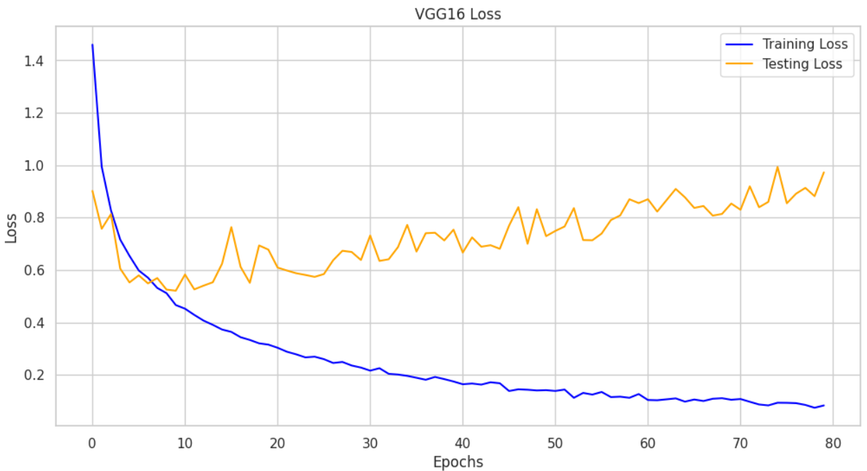
Fig 11. Training and testing loss for VGG16 model

The loss curves shown in Fig 11, illustrate a consistent reduction in training loss, confirming that the model is optimizing effectively on the training dataset. However, the testing loss begins to increase after approximately 20 epochs, diverging significantly from the training loss. This upward trend in testing loss, contrasted with the decreasing training loss, further highlights overfitting in the model.
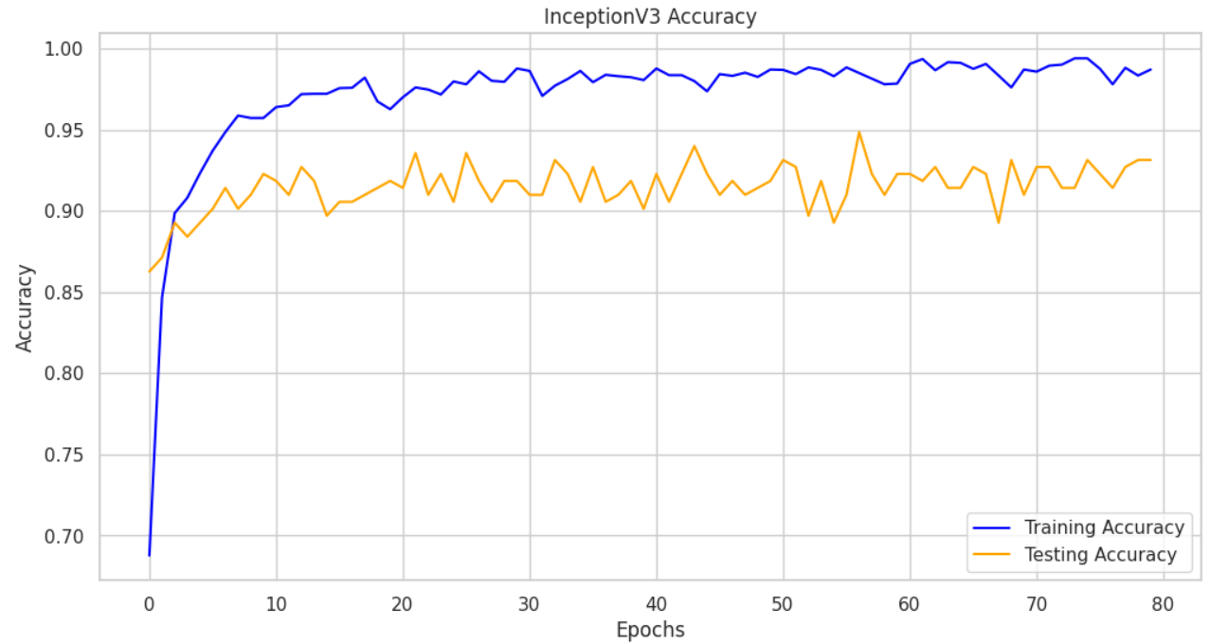
Fig 12. Training and testing accuracy for InceptionV3 model

The InceptionV3 model demonstrates impressive performance in both training and testing, achieving a training accuracy of 98.70% and a closely aligned testing accuracy of 93.13%. This high testing accuracy, which is near the training accuracy, suggests that the model exhibits strong generalization capabilities. It effectively captures complex data patterns without overfitting, reflecting its ability to generalize well to unseen data. The consistency in performance between the training and testing sets as shown in Fig 12, underscores InceptionV3's proficiency in modeling intricate data structures while avoiding excessive memorization, making it a reliable choice for tasks that require robust generalization.
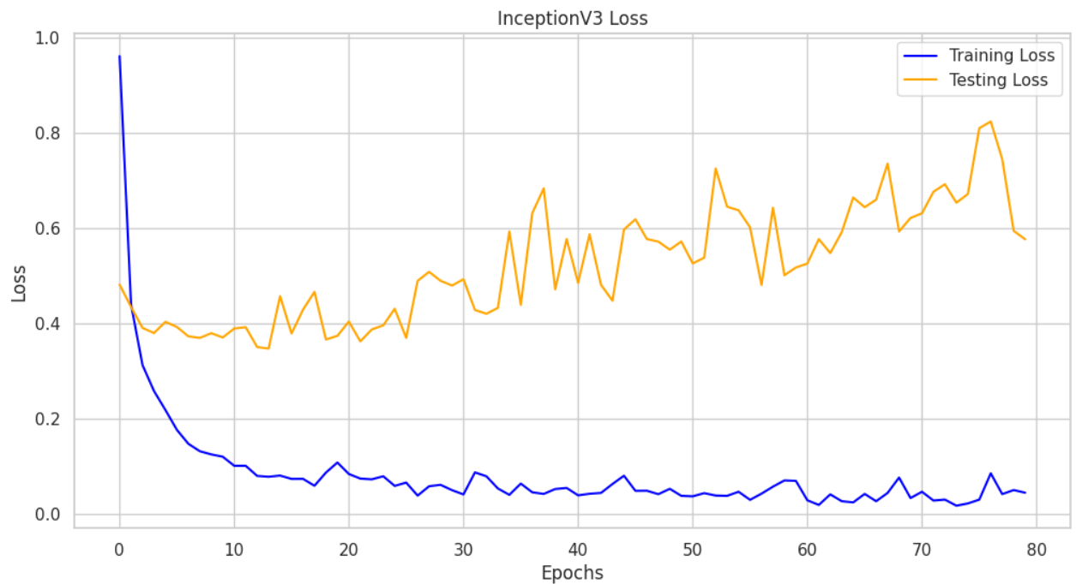
Fig 13. Training and testing loss for InceptionV3 model

The InceptionV3 model exhibits notable trends in loss values for both the training and testing sets, with the training loss steadily decreasing over time as illustrated in Fig 13. This decrease indicates that the model is effectively optimizing on the training set. The testing loss mirrors this trend, remaining stable and suggesting that the model does not experience overfitting. The consistency between the training and testing loss values, alongside high testing accuracy, highlights InceptionV3's ability to maintain strong performance on unseen data. This can be attributed to the model's advanced architecture, which likely offers better regularization allowing it to better capture the underlying patterns in the data.
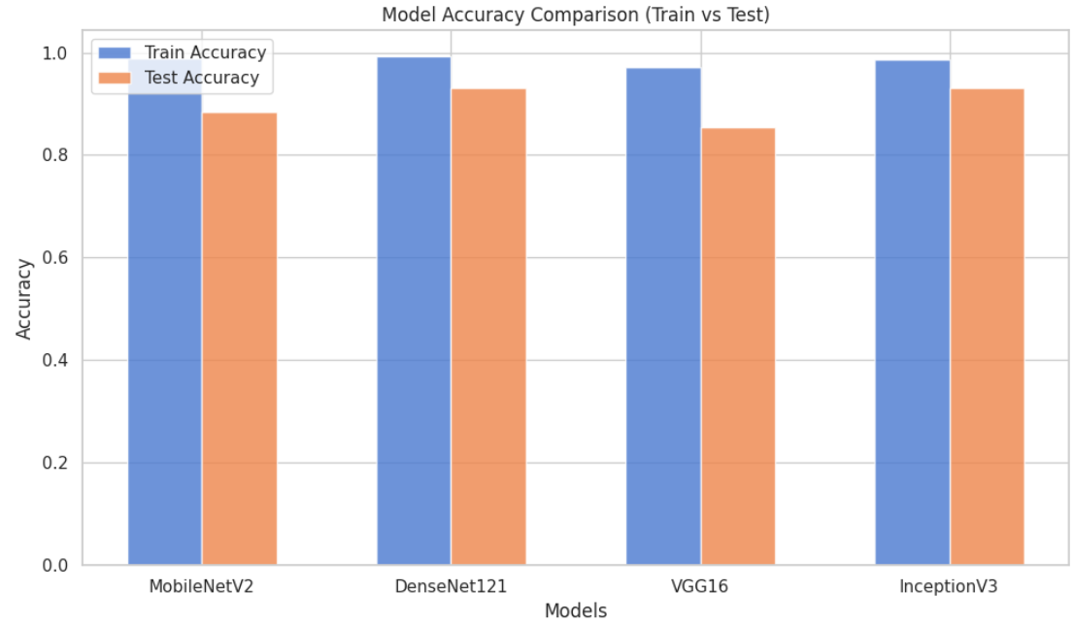
Fig 14. Accuracy comparison of all models

The bar chart shown in Fig 14, presents a comparison of the training and testing accuracies across four deep learning models: MobileNetV2, DenseNet121, VGG16, and InceptionV3. MobileNetV2 demonstrates strong generalization with a modest discrepancy between training and testing accuracy. DenseNet121 achieves the highest training accuracy among the models, with a closely aligned testing accuracy, indicating robust generalization and minimal overfitting. VGG16 exhibits a more significant gap between training and testing accuracy, suggesting potential overfitting. InceptionV3, akin to DenseNet121, shows high training accuracy with a smaller gap in testing accuracy, reflecting favorable generalization.
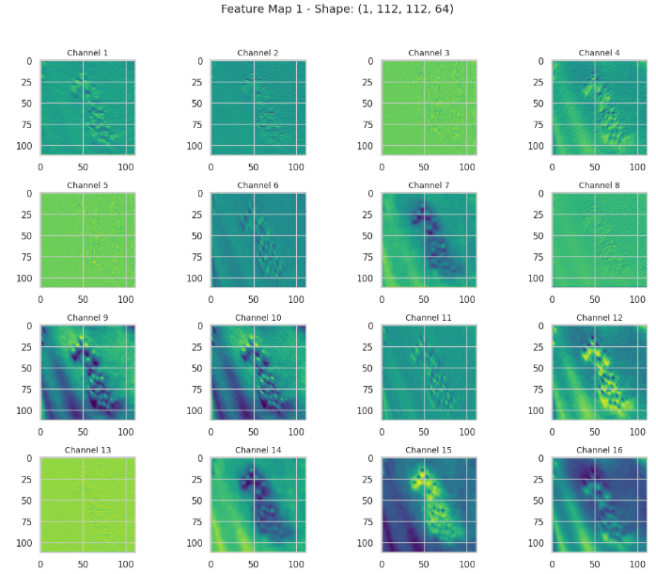
Fig 15. Feature map for DenseNet121 model

Fig 15 visualizes the feature maps produced by a pre-trained DenseNet121 model, illustrating its hierarchical feature extraction process. DenseNet121, a convolutional neural network comprising 427 layers, processes an input image of dimensions 224 x 224 x 3, generating feature maps with reduced spatial dimensions and 64 channels, each capturing distinct feature representations. A submodel, comprising the first and last five layers (425 layers in total), was constructed to analyze feature extraction across the network. The visualized feature maps display the activations of the first 16 channels, with brighter intensities indicating stronger activations. Early layers predominantly capture fundamental patterns such as edges and textures, while deeper layers progressively extract more localized and intricate features. This hierarchical progression underscores DenseNet121's ability to transition from basic structural patterns to complex representations, offering valuable insights into its feature learning and processing capabilities.
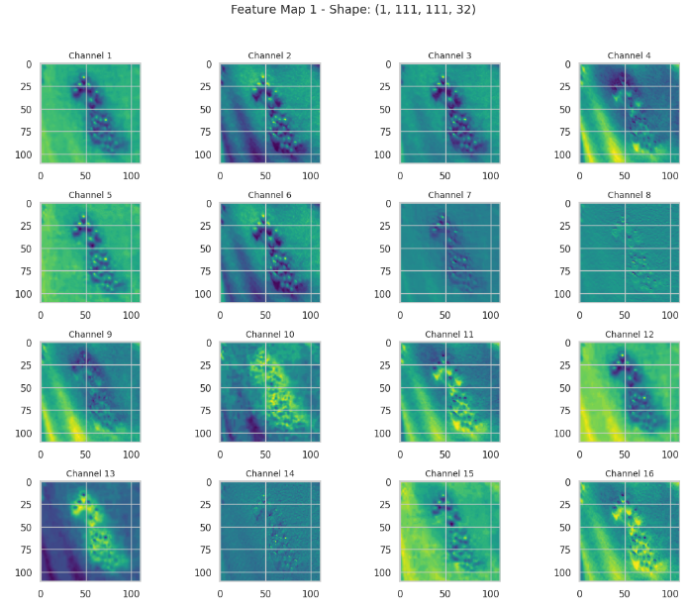
Fig 16. Feature map for InceptionV3 model

Fig 16 showcases feature map visualizations generated by the InceptionV3 model, a 311-layer convolutional neural network widely recognized for its applications in image classification and feature extraction. An input image, preprocessed to dimensions 1×224×224×3, produces intermediate feature maps with a shape of 1×111×111×32, reflecting spatial downsampling and 32 feature channels. A submodel targeting specific layers extracts these maps, with the first 16 channels displayed in a grid format. Each channel captures unique patterns, transitioning from basic edges and textures in early layers to complex shapes and abstract features in deeper layers. Bright regions indicate areas of strong activation, highlighting the network’s focus on critical features of the input. These visualizations offer insights into the hierarchical learning process, supporting interpretability and debugging by illustrating how the model progressively identifies and refines meaningful patterns.

Model Integration
Following the individual evaluations, the top two performing models, DenseNet121 and InceptionV3 are integrated into a combined architecture to leverage their respective strengths. The combined architecture is trained and tested over 80 epochs to optimize both accuracy and efficiency. The refined model is evaluated using key metrics, ensuring its effectiveness and robustness in diagnosing skin conditions.
The combined model architecture integrates two pre-trained feature extractors, InceptionV3 and DenseNet121, along with custom dense layers for classification. This hybrid model combines DenseNet121 and InceptionV3 for feature extraction, leveraging DenseNet’s densely connected layers and Inception’s multi-scale processing capabilities. Input images (224x224x3) are processed in parallel by both networks, producing feature maps of sizes 1024 and 2048, respectively, which are then pooled and concatenated into a 3072-dimensional vector. This representation is refined through a Dense layer with 32 units, followed by Dropout for regularization, and an 8-unit Dense output layer for classification. The model includes 31,995,240 parameters, with only 3,154,952 trainable, likely due to freezing the base models. This architecture optimizes feature diversity for improved classification performance.
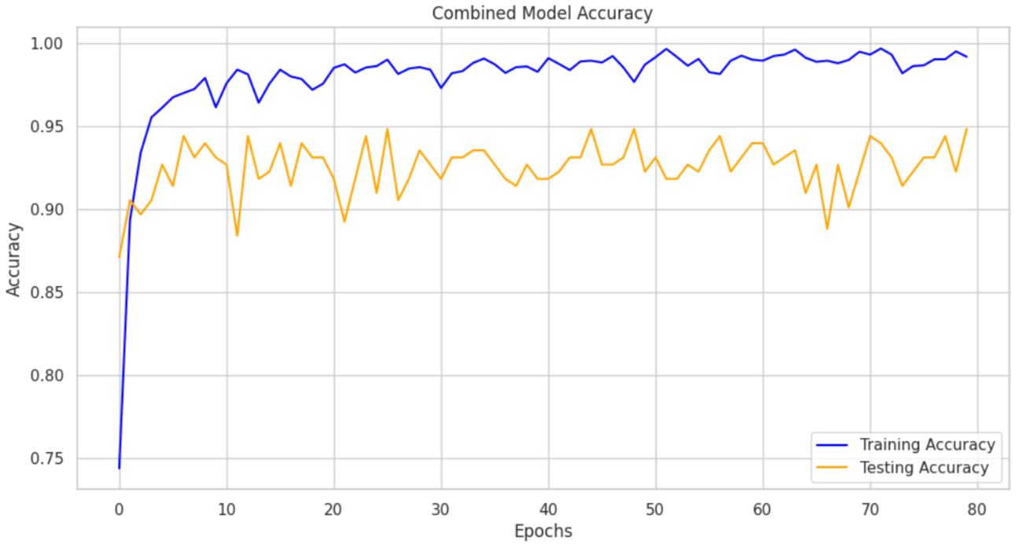
Fig 17. Training and testing accuracy for the proposed combined model

The combined model exhibits strong performance, with a training accuracy of 99.20% and a testing accuracy of 94.85%. The close alignment between training and testing accuracy as shown in Fig 17, indicates that the model generalizes effectively to unseen data, capturing complex patterns without significant overfitting. Although a small generalization gap exists, the model demonstrates a balanced ability to learn from the training data while maintaining its performance on the test set. This suggests that the model has successfully avoided excessive memorization and has learned broader data representations. These results highlight the model’s robustness and reliability for tasks requiring high accuracy and generalization.
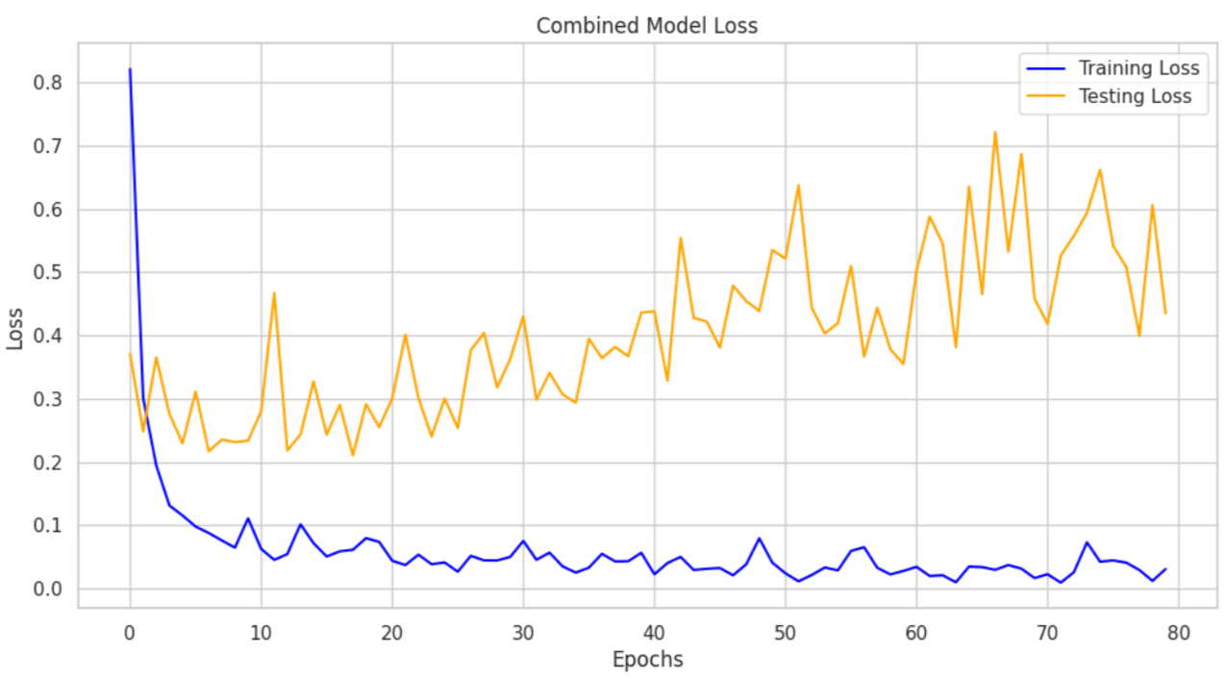
Fig 18. Training and testing loss for the proposed combined model

The line graph as shown in Fig 18, illustrates the training and testing loss of a machine learning model over 80 epochs, with loss values quantifying prediction error, where lower values indicate better model performance. The blue line represents the training loss, which starts at approximately 0.8, decreases steadily, and stabilizes near 0.05, demonstrating effective model fitting to the training data. In contrast, the orange line for testing loss shows an initial decline followed by significant fluctuations between 0.2 and 0.5, with a slight upward trend in later epochs. This variability, coupled with the widening gap between training and testing loss, suggests overfitting, where the model memorizes the training data rather than generalizing well to unseen data.
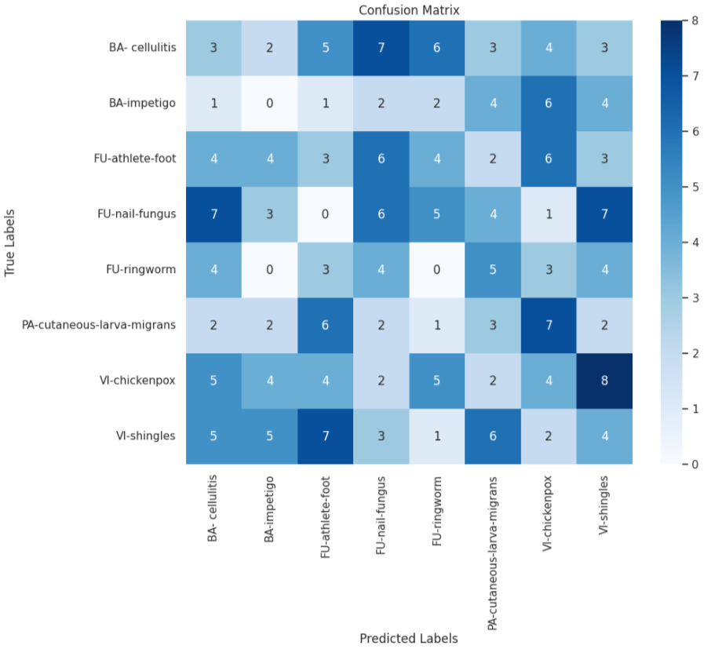
Fig 19. Confusion matrix

Fig 19 presents a confusion matrix, a standard tool for evaluating the performance of classification models by comparing true labels with predicted labels. The rows represent the actual disease categories, while the columns correspond to the predicted categories. Diagonal cells indicate correct predictions, and off-diagonal cells highlight misclassifications. The matrix is color-coded, with darker shades of blue indicating higher prediction counts. Notable findings include strong performance for classes like VI-chickenpox and VI-shingles, while classes such as BA-impetigo show low correct predictions. Misclassifications, such as confusion between BA-cellulitis and FU-athlete foot, suggest challenges in distinguishing similar conditions.
The integration allows the model to significantly outperform the individual models, where MobileNetV2 achieved an accuracy of 88.41%, DenseNet121 reached 93.13%, VGG16 attained 85.41%, and InceptionV3 recorded 93.13%.

IV. Conclusion
This study introduces a novel and effective approach to improving skin disease detection through the integration and optimization of advanced deep learning models. By combining the capabilities of InceptionV3 and DenseNet121, the proposed model achieves superior performance compared to standalone models, as evidenced by its excellent accuracy. Combining features from these models, facilitated by global average pooling, comprehensive data augmentation and strategic hyperparameter tuning, has yielded a highly effective diagnostic system. The evaluation metrics demonstrate the model's proficiency in accurately identifying various skin diseases, making it an invaluable asset for dermatological assessments and clinical decision-making.

Future research will focus on enhancing model performance through key advancements. We will utilize Generative Adversarial Networks (GANs) to augment the training dataset, improving generalization across diverse skin types. GANs will also help generate synthetic data for rare or underrepresented conditions, further strengthening the model's robustness. Additionally, the hybrid CNN architecture will be adapted for real-time diagnostic applications on mobile and embedded systems, enabling rapid diagnosis in clinical and resource-limited environments. Finally, we will integrate Explainable AI (XAI) techniques to provide transparency in decision-making, fostering clinician trust and supporting informed, data-driven medical decisions.

References

- W. Gouda, N. U. Sama, G. Al-Waakid, M. Humayun, and N. Z. Jhanjhi, "Detection of skin cancer based on skin lesion images using deep learning," Healthcare, vol. 10, no. 7, p. 1183, 2022.
- U.-O. Dorj, K.-K. Lee, J.-Y. Choi, and M. Lee, "The skin cancer classification using deep convolutional neural network," Multimedia Tools Appl., vol. 77, no. 8, pp. 9909–9924, 2018.
- R. S. Kumar, A. Singh, S. Srinath, N. K. Thomas, and V. Arasu, "Skin cancer detection using deep learning," in Proc. Int. Conf. Electron. Renew. Syst. (ICEARS), pp. 1724–1730, 2022.
- K. Mittal, K. S. Gill, M. Kumar, and R. Rawat, "Innovations in Skin Diagnostic Technologies: Utilizing a DenseNet201 Deep Learning Model for the Early Detection of Skin Cancer," in 2024 IEEE International Conference on Information Technology, Electronics and Intelligent Communication Systems (ICITEICS), pp. 1–4, 2024.
- S. Remya, T. Anjali, and V. Sugumaran, "A Novel Transfer Learning Framework for Multimodal Skin Lesion Analysis," in IEEE Access, vol. 12, pp. 50738–50754, 2024.
- M. Nawaz, T. Nazir, M. Masood, F. Ali, M. A. Khan, U. Tariq, N. Sahar, and R. Damaševičius, "Melanoma segmentation: A framework of improved DenseNet77 and UNET convolutional neural network," Int. J. Imag. Syst. Technol., vol. 32, no. 6, pp. 2137–2153, 2022.
- S. Chatterjee, J.-M. Gil, and Y.-C. Byun, "Early Detection of Multiclass Skin Lesions Using Transfer Learning-Based IncepX-Ensemble Model," in IEEE Access, vol. 12, pp. 113677–113693, 2024.
- Y. N. Fu’adah, N. C. Pratiwi, M. A. Pramudito, and N. Ibrahim, "Convolutional neural network (CNN) for automatic skin cancer classification system," in IOP Conf. Ser., Mater. Sci. Eng., vol. 982, no. 1, Art. no. 012005, 2020.
- O. O. Abayomi-Alli, R. Damaševičius, S. Misra, R. Maskeliunas, and A. Abayomi-Alli, "Malignant skin melanoma detection using image augmentation by oversampling in nonlinear lower-dimensional embedding manifold," Turkish J. Electr. Eng. Comput. Sci., vol. 29, no. SI-1, pp. 2600–2614, 2021.
- L. Wei, K. Ding, and H. Hu, "Automatic skin cancer detection in dermoscopy images based on ensemble lightweight deep learning network," in IEEE Access, vol. 8, pp. 99633–99647, 2020.

